Construction
- Polyamid bristles which are caste in a special glue layer at an angle of 70°.
- Total thicknesses: 2.1 mm
- Bristle length: 2,5 mm
- max. Sizes: width 650 mm length of 50 m
- SynBrush is available with or without adhesive backing
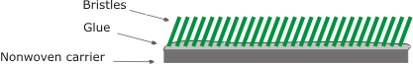

How it works
The material to be conveyed is in resting position on the bristle | 
Now if the conveyer system moves forward, the bristles bend themselves against their original inclination to the rear, whereby the part, conditionally by the remainder inclination, remains lying on the same bristles. The slipping back of parts is pre  vented | 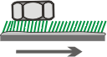
During the forward movement the part, like with uncoated plants, is raised by those inclined/slanted spring rods and transported forward with a diagonal throw a small piece. The tendency of the bristles, the starting position of approx.. 70` again to assume, strengthens the forward movement | 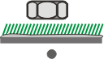
During the "throw" the conveyer system withdraws itself again and the part hits the bristles in the meantime in resting position. Here the edition appropriate bristles are depressed and the impact energy of the part by the bristles is caught. | 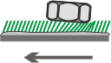

Advantages
- An increase in performance of up to 300% or more is possible depending an the parts to be conveyed.
- No influence of oils and emulsions an the conveying capacity.
- No dirtying of the plant due to erosion of parts.
- A dramatic reduction in noise levels.
- Very short amortisation periods in some cases.
- No damage arises to parts which have sensitive surfaces or which are fragile such as plastics or ferrite.
- No damage to the plant due to the presence of parts which have burr an them or sharp edges.
- The even quiet running of parts throughout the whole conveying area offers better behavioural characteristics in the sorting area.

